Vector Algebra Homework (20 Points)
(jas, Vector Algebra HW.docx, 10/14/2025)

Use units and clearly label answers using 3 or 4 significant digits where appropriate. Show your work so that if necessary partial credit can be awarded.

- Using the conversion relationships given in Table 3-2, convert the point P = (2, 4, 7) from the Cartesian (rectangular) coordinate system to:

- Cylindrical Coordinates using degrees for angles. (3 Points.)
$$R= \sqrt[+]{x^{2}+y^{2}};θ=\tan^{-1}\left(\frac{y}{x}\right);z=z$$
$$R= \sqrt[+]{2^{2}+4^{2}}=4.47;θ=\tan^{-1}\left(\frac{4}{2}\right)=63.4° ;z=7$$
$$P(4.47, 63.4°, 7)$$

- Spherical coordinates using degrees for angles. (3 Points.)
$$R= \sqrt[+]{x^{2}+y^{2}+z^{2}};θ=\tan^{-1}\left(\frac{\sqrt[+]{x^{2}+y^{2}}}{z}\right); ϕ= \tan^{-1}\left(\frac{y}{x}\right)$$
$$R= \sqrt[+]{2^{2}+4^{2}+7^{2}}=8.31 ;θ=\tan^{-1}\left(\frac{\sqrt[+]{2^{2}+4^{2}}}{7}\right)=32.6°; ϕ= \tan^{-1}\left(\frac{4}{2}\right)=63.4°$$
$$P(8.31, 32.6°, 63.4°)$$

- Calculate the dot product between the two vectors A = [-3, 7, 8], and B = [-40, 57, 1], first by hand including intermediate steps (2 points), then by using the MATLAB dot() function (2 points). (4 Points total.)
$$A∙B=A_{1}B_{1}+A_{2}B_{2}+A_{3}B_{3}=\left(-3\right)\left(-40\right)+\left(7\right)\left(57\right)+\left(8\right)\left(1\right)=527$$
$$A∙B=527$$

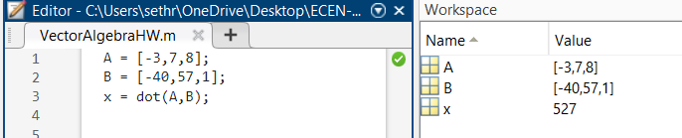

- Calculate the cross product between the two vectors A = [-3, 2, 9], and B = [1, -7, 2], first by hand including intermediate steps (2 points), then by using the MATLAB cross() function (2 points). (4 Points total.)

$$A x B={(A}_{y}B_{z}-A_{z}B_{y})+{(A}_{z}B_{x}-A_{x}B_{z})+{(A}_{x}B_{y}-A_{y}B_{x})$$
$$=\left(\left(2\right)\left(2\right)-\left(9\right)\left(-7\right)\right)+\left(\left(9\right)\left(1\right)-\left(-3\right)\left(2\right)\right)+\left(\left(-3\right)\left(-7\right)-\left(2\right)\left(1\right)\right)=\left(67,15,19\right)$$
$$A x B=(67,15,19)$$

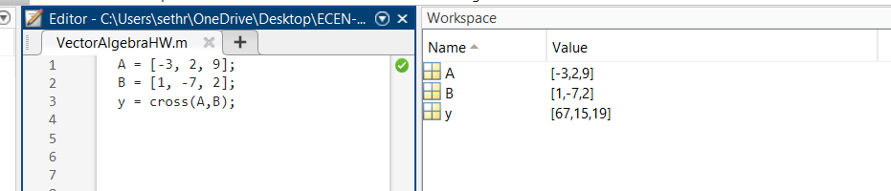

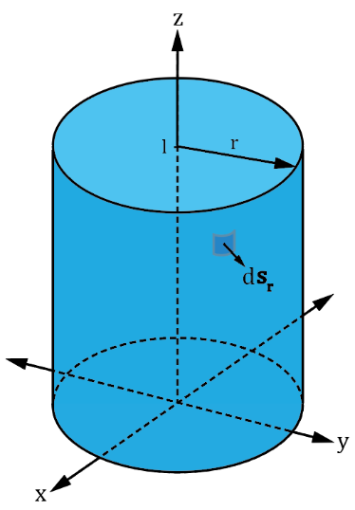
- Given $ds_{r}$ as illustrated in the adjacent diagram, derive the surface area of a cylinder of radius r and height l, not including the end caps. Include at least 2 steps of your derivation below with your answer as a function of r and l.
(3 points.)

$$\int_{z=0}^{l}{\int_{ϕ=0}^{2π}{rdϕdz}}=\int_{0}^{l}{r \left[2π-0\right] dz}=\int_{0}^{l}{2πrdz}=2πr\left[l-0\right]=2πrl$$

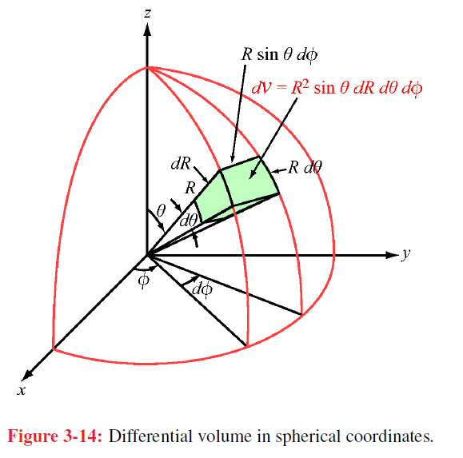
- Given $ds_{R}=\hat{R}{(R}^{2}sinθ)dθdϕ$ as illustrated in the adjacent diagram, derive the surface area of a sphere of radius R, including at least 2 steps of your derivation below with your answer as a function of R. (Hint: Vary 𝜙 from 0 to 2π in your integration.) (3 points.)

$$\int_{ϕ=0}^{2π}{\int_{θ=0}^{π}{R^{2}\sin\left(θ\right)dθdϕ}}=R^{2}\int_{0}^{2π}{\int_{0}^{π}{\sin\left(θ\right)dθdϕ}}$$
$${=R}^{2}\int_{0}^{2π}{{\left[-\cos\left(θ\right)\right]}_{0}^{π} }dϕ= {=R}^{2}\int_{0}^{2π}{[-\cos\left(0\right)-\left(-\cos\left(π\right)\right)] }dϕ {= R}^{2}\int_{0}^{2π}{2}dϕ$$
$$={2R}^{2}\int_{0}^{2π}{dϕ}={2R}^{2}{\left[ϕ\right]}_{0}^{2π}={2R}^{2}\left[2π-0\right]=4πR^{2}$$

